UNIT-2 : Project Administration

* Once a project has been established and the goals are set, the project manager has to act to achieve these goals.
* Concept to completion of a project need the co-ordination and concerted efforts by various professionals, for hassle - free execution.

# Essentials of Project Administration

* + - The chief executive has to issues **project chart**, which is necessary to execute project in any company.
    - Project chart must define the **project scope**, the **project goals**, **name and authority delegated project manager, project reviewing authority** and **request co-operation of all concerned in the execution of the project**.
    - An elaborate effort in this direction may produce a **project manual.**
    - To demonstrate the project manager’s authority in a simplest and quickest way it is essential to develop a proper **organization chart.**

There are **two systems for the management of project** and they are:

## Project work system

1. **Project control system**
2. **Project work system:** Project work system can be designed by developing and preparing the following tools

## Work breakdown structure

* + **Project execution plan**

## Project procedure manual etc.

1. **Project control system:** Project control system can be designed by developing and preparing the following tools

## Project planning

* + **Project scheduling**
  + **Project monitoring.**

# Project Team

A project team plays an important role of **designing and implementing** a project or programme. The team members are ***responsible for the planning and execution of the project***. A project team consists of a specific group of individuals.

## Types of a project team:

* + - Initial project team
    - Designated project leader/manager
    - Core project team
    - Full project team
    - Project advisors
    - Project stakeholders
    - Process facilitators

## Initial project team:

* + - The initial project team consists of specific people **who initially plan the idea of starting** a project.
    - The members of this **team may or may not be part of the core project team.**

## Designated project leader/manager:

* + - He has the overall control of the project. He shoulders the responsibilities for the execution and performance of the project.

## Core project team:

* + - The core project team is a small group of people consisting of 3 to 8 people. They are responsible for **designing and managing a project.**
    - This team also called as **project steering committee** consists of **sponsor, client** **leader, expert/specialist and internal auditor**.

## Full project team:

* + - This team consists of complete group of people involved in **designing, implementing, monitoring and learning from a project.**

## Project advisors:

* + - Project advisors are the people **who are not in the project team**, but finally to whom the team members can depend for honest feedback and counseling . and who can anchor the cause of the project.

## Project stakeholders:

* + - Project stakeholders are the **individuals, groups or institutions** . They have a complete **interest in the natural resources of the project area**. They will be affected by the **project activities and have something to gain or lose** .
    - It is not mandatory that all the stakeholders should be part of the project team. The key stakeholder will find a place in the project team.

## Process facilitators:

* + - A process facilitator is a person who can **help the project team through the planning process.**
    - A process facilitator is **part of the initial and/or the core team.**

## The advantages of effective team :

* + - **Clear objective** of the project from the initial stage to final stage.
    - **Good decision-making process**. This **speed up the activities**.
    - Clear roles, responsibilities and leadership without overlapping. This ensures **smooth progress**.
    - Leadership roles are shared by team head.
    - Trust, co-operation, support and constructive conflict or feedback is essential.
    - Individual and mutual accountability for performance results is the highlight of the projects success.

**Pitfalls of ineffective project team:**

1. Falling performance level with ambiguous instructions.
2. Low level of motivation.
3. Poor communication from the project manager.
4. Poor or slow decision making by team head.
5. Confusion about responsibilities.
6. Role and territory conflicts among the team.

## Factors to be considered while selecting project team members.

* + - Knowledge of bio- diversity and threat to bio-diversity.
    - Knowledge of political, social and economic context
    - Knowledge/experience of stakeholders and their concerns
    - Skill/experience in developing strategies
    - Experience in implementing strategies
    - Experience in communications and fund raising
    - Experience in budgeting and risk assessment
    - Should understand the psychology of the team
    - Should not be short tempered.

# Project Design

* Project design is the **first stage** in the execution of the project.
* Project design is concerned with:
* i) developing **project scheduling techniques.**

ii) It is **drawing the schedule for implementation of the project**.

* It includes major items of project implementation such as **finding the location, construction of buildings, purchasing plant and machinery and finally** execution of the production programme.

## Project design is useful to the entrepreneurs in the following ways:

* + - It is a **diagrammatic representation of the work** plan designed to execute the project.
    - It gives a **complete idea about the entire project** .
    - It describes **every phase of a project**.
    - It gives the idea about the **time schedule within** which it has to be completed.
    - The various activities of the project are narrated in sequence. This helps in highlighting the **various phases of the project**.
    - It **enables to identify how events must take** place for the successful completion of the project.
    - It helps **entrepreneurs in coordinating project activities**.
    - It serves as an **effective tool of planning and implementation of a project.**
    - It helps **managers to plan the project economically.**

# Work Breakdown Structure (WBS):

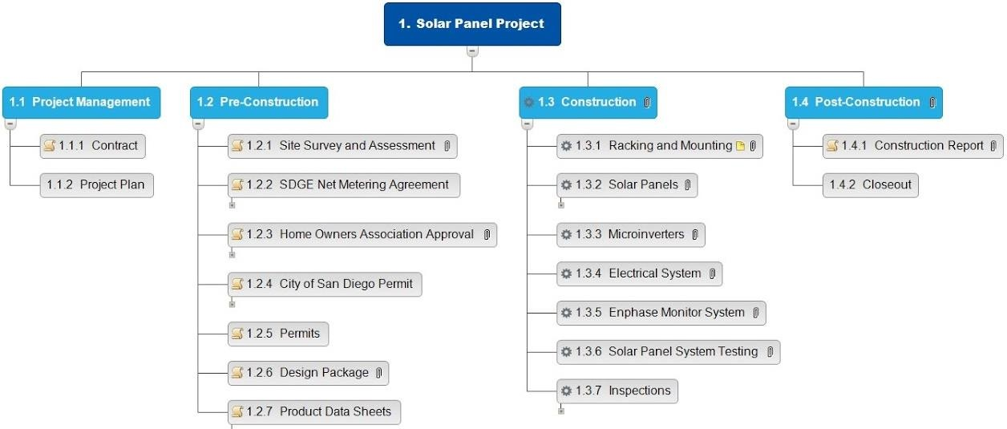

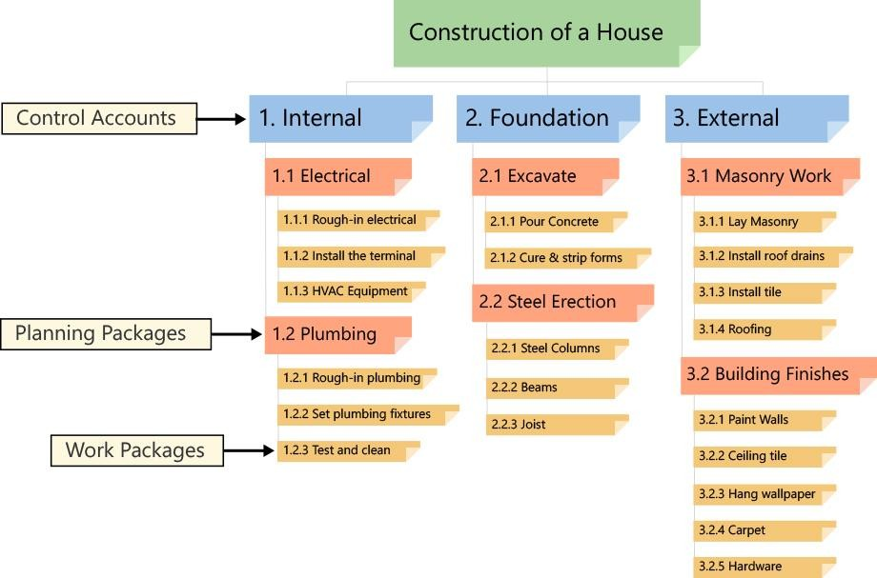

* Work breakdown structure (WBS) is a technique which breaks down a work into its components. It establishes the connections between the components on the lines of a family tree.
* The work breakdown structure defines what work is to be done in a detailed manner.
* The work breakdown structure is a **systematic and logical breakdown of the project into** its component parts.
* It is done by **dividing the project into its major parts. The** major parts are further divided into sub-parts.
* Breakdown is done in terms of **manageable units of work.** The responsibility is defined for these manageable units of work
* A WBS can be very simple (a spreadsheet) or very complex (charts and tools), depending on the needs of the project.
* Items at the lowest level are called **work packages**
* **Planning packages** are located between **work packages and control accounts**

## Advantages of WBS:

* + - Work break down in terms of manageable unit of work helps in planning, budgeting, and controlling of project.
    - This helps in Assigning responsibility for work elements to project personnel and outside agencies.
    - Development of control and information system.
    - Useful as a team development tool
    - Helps in documentation and detailed planning
    - Useful for estimation of time and cost (resources)
    - It is not time based
    - Work that is not part of WBS is outside the scope of the project.
    - It forms the scope Baseline
    - Helps to provide better communication between project team and stakeholders and clarifies responsibilities.

## Work breakdown structure and Project organization

* + - The project organization represents formally how the project personnel and outside agencies are going to work.
    - The work breakdown structure defines what work is to be done in a detailed manner. To assign responsibility for the tasks to be done, the work breakdown structure has to be integrated with the project organization structure.

# Project Execution Plan (PEP)

* Project execution plan (PEP) refers to exercise of matching the project hardware and software with the executing agencies so that a successful work system emerges.
* Project execution is a strategic plan. It does not deal with the operational details of building a project.
* The operational details are covered in a network plan which is developed later after the project execution plan is approved
* It is the basis for development of all operational plans including network plans.
* Project execution plan includes four sub-plans. These are

1. Contracting Plan
2. Work packaging Plan
3. Organization Plan
4. Systems and Procedure Plan

# 1. Contracting Plan

* This is the first step in the preparation of a project execution plan.
* Owners need some agencies with whom they can share responsibilities.
* In the interest of developing self-regulating systems it would be necessary to contract out those areas where the owner’s company does not have inherent competence (skill, knowledge and ability).
* Contract planning would involve examination of a number of alternatives in terms of sharing of responsibilities, types of reimbursements and general conditions of contract.

# . Work Packing Plan

* Work packing plan will be next important step in the preparation of the project execution plan.
* A work package is a group of related tasks within a project.
* Work packages are the smallest unit of work that a project can be broken down into when creating your Work Breakdown Structure (WBS).
* Work packaging enables better organization and management of projects.
* A work package or several work packages may be assigned to one individual who could serve as a mini project manager.
* Work packaging can also ensure that all agencies in the project work towards the completion of the packages only.
* A work package in a project is the smallest division of work where it still retains the characteristics of a project.

# . Organization Plan

* Having decided the number of contracts and their scope, the owner is now in a position to set his own house in order.
* The owner can engage on the form of organization to be adopted so that the interest of the project is best served.
* Several standard organizational arrangements are possible and an owner has to choose his own arrangements depending on the project size, location, complexity, work packages, type and number of contracts.
* It should be however , noted that an organization can become more self regulating if it is on task force or projectised.
* The participants in such cases fully identify themselves with the project objectives and would regulate their behavior on their own, as the situation may demand.

# Systems and Procedure Plan

* This is last section of the project execution plan .
* More importance has to be on routine systems and procedure so that no interference is required in the day-to-day operation of a system.
* The routine sub-systems of project management are;.
  1. Contract management
  2. Configuration management
  3. Time management
  4. Cost management
  5. Fund management
  6. Materials management
  7. Communication management
* While the routine systems and procedure for each company will be different, in most of the cases the difference may not be very significant.
* It is quite possible to examine the systems and procedure of one project and adopt it after making minor modifications.

# Project Procedure Manual

* A project procedure manual is to be prepared in such a way that the interacting agencies are able to see their roles and mutual relationships in achievement of the common goal.
* Preparation of a project procedure manual should start with each project management sub system.
* The Project Procedure and Execution Manual contains the instructions for handling the work on this project in accordance with the terms of the contract.
* It is a descriptive manual for how to manage the process of project management.
* Major sections of Project Procedure Manual are: 1) define and organize the project,
  1. plan the project, and
  2. track and manage the project.
* The roles and procedure shall be documented in project procedure manual. This is prepared by project manager.

# Project Diary

* In order to ensure effectiveness, project manager or executive have to maintain a record date wise, the point discussed and decision taken which are required to be followed for implementation. This is known as **project diary.**
* Project diary is a narrative record of discussion.
* A project manager would be holding a number of meetings with vendors, contractors, own staff and taken many decision in these meetings and many commitments are made. The Information or decisions arrived have to be properly recorded in the project diary.
* The Information in dairy will help to justify the decisions at later date.
* The record may also be used to defend against non-admissible claims and disputes.
* This diary helps to prepare a follow-up register also. The follow-up register will contain all pending work with dates committed against each.
* Maintaining diary helps the person to get relief from the burden of carrying everything in their head.
* It could boost up one’s memory thereby helps to avoid the problems of unattended work due to lack of memory.
* Hence, all project executives need to maintain project diaries for efficient management of project.

# Project Execution System

* Once these systems and procedures have been developed for the project, it is the duty of the project administrator for smooth execution of the project.
* Proper project execution system is required to address the concerned about external intervention (involvement) for survival than on its internal self-regulating capacity.
* The external intervention (involvement) will be of the following forms:

1. Project direction
2. Project communication
3. Project co-ordination
4. Project organization
5. Project control

* These terms are often constructed as actions for getting results. The successful execution and administration of project requires direction, organization, co-ordination, communication and control of project in varying proportion.

# Project Direction

* Project direction refers to the use of authority to channelize (focus on) the activities of the project on desired lines.
* During the initiation of start-up period of the project this direction shall be provided by the project manager.
* Once the project enters the production period, direction will be exercised by other members of the project organization as per the project design.
* Project direction is maximum at the time of start-up of implementation. The project manager during this period needs to provide directions relating to:

1. Scope of work
2. Specifications of results of completed work
3. Basis of work
4. Division of work
5. Schedule of work
6. Budget of work
7. Systems and procedure for work
8. Co-ordination of work
9. Authority and accountability for work
10. Control of work

* The success of a project is heavily dependent on team work**.** All the items from 1 to 10 are completed with the involvement of project participants.

# Project Communication

* Projects happen only through communication. In modern times, speed isn't the communication bottleneck, quality is the communication bottleneck.
* For a successful directions a two-way communications systems is essential. For that matter, the entire process of direction, co-ordination and control in a project revolves around communication.
* It is often concluded that projects are run by communications.
* According to Peter. F. Drucker, 63% of management problems are caused in whole or in part by faulty (defective) management communications.
* Relationships and communication are not low-priority work. They are essential to all of the individual activities that take place during a project.
* Communications has two dimensions:
  1. Physical dimension: passing a memo, drawing, data, instruction, information, etc. are the physical aspects of communication. Physical aspects of communications can be easily achieved
  2. Mental dimension: Understanding the role expectation, empathy, preconceived notions, language barriers, listening skills etc., are the mental aspects of communication. The mental aspects often present barriers to communication.

Common communication problems or barriers of communication:

* + - Assumption
    - Lack of clarity
    - Not listening
    - Dictation
    - Problem mismatch
    - Personal/ad hominem attacks
    - Derision, ridicule, and blame

# Project Co-ordination

* A project is a group effort and in a group there will be always be differences of opinion. But coordination is not merely smoothing out differences; it is reintegration of subdivided functions and their interests.
* Co-ordination can be defined as the effort to bring parts into super relation for harmonious functioning. A well-coordinated project is as pleasing as a piece of music.
* Co-ordination in a project gains its importance because of the need for simultaneous working of number of activities. Therefore, one cannot proceed simply, with the execution of a project without proper co-ordination.

## Project Co-ordination Procedure:

Co-ordination basically addresses itself to **two aspects of work** –

* + - **Physical aspect:** It would refer to what is to be done, how much is to be done and who will do it;
    - **Timing aspect :** It would refer to when these will be done.
    - A schedule document which deals with all these aspects of work should be prepared to enable proper co-ordination..
    - The word breakdown structures (WBS) provide the basic frame work for both physical and time aspects.

Once the stage is so set, the day to day co-ordination in a project is ensured through

1. Squad check
2. Co-ordination meeting and
3. Communication

# Pre-requisites for Successful Project Implementation

* Time and cost over-runs of projects are very common in India, particularly in the public sector.
* Due to such time and cost over-runs, projects tend to become uneconomical, there will be unavailability of resources to support other projects, and economic development is adversely ( negatively) affected.
* To minimize time and cost over-runs and for the successful Implementation of projects, the Pre-requisites are as below:

1. Adequate formulation.
2. Sound project organization.
3. Proper implementation planning.
4. Advance action.
5. Timely availability of funds.
6. Judicious equipment tendering and procurement.
7. Better contract management.
8. Effective monitoring.

## Adequate Formulation:

Deficiency in project formulation is due to:

* + - Insufficient field investigation
    - Uninterested assessment of input requirements
    - Unorganized methods used for estimating costs and benefits
    - Omission of the project linkages
    - Incorrect judgments because of lack of experience and expertise
    - Undue hurry to get started
    - over-estimation of benefits and under-estimation of costs

## Sound Project Organization:

A sound organization for implementing the project is very much needed to its success. The characteristics of such an organization are:

* + - It is led by a competent leader who is responsible for the project performance.
    - The authority of the project leader and his team is measured with common standard with respect to their responsibility
    - Greater attention is paid to the human side of the project
    - Systems and methods are clearly defined
    - Rewards and penalties to individuals related to their performance.

## Proper Implementation Planning:

For proper implementation planning

* + - Develop a complete time plan for various activities like land acquisition, tender evaluation, construction of buildings,etc..
    - Estimate carefully the resource requirements (manpower, materials, money, methods etc.) for each period to realize the time plan.
    - Define properly the inter-linkages between various activities of the project.
    - Specify cost standards.

## Advance Action:

When the project appears to be workable and advantageous, advance action on the following activities may be started:

* 1. acquisition of land,
  2. securing essential clearances,
  3. identifying technical collaborators/consultants,
  4. arranging for infrastructure facilities,
  5. preliminary design and engineering and
  6. Calling of tenders.

## Timely Availability of Funds:

Once a project is approved, adequate funds must be made available to meet its requirements as per the plan of implementation - it would be highly desirable if funds are provided even before the final approval to initiate advance action.

## Judicious Equipment Tendering and Procurement:

To minimize time over-runs, it may appear that a turnkey contract has obviously advantageous. The contracts are likely to be bagged by foreign suppliers, when global tenders are floated.. A judicious balance must be sought which moderates the outflow of

Foreign exchange and provides reasonable fillip to the development of indigenous technology.

1. **Better Contract Management:** Since a substantial (considerable) portion of a project is executed through contracts, the proper management of contracts should be done:

* The competence and capability of all the contractors must be ensured.
* Proper discipline must be developed among contractors and suppliers.
* Penalties must be imposed for failure and incentives may be offered for good performance.
* Help should be extended to contractors and suppliers when they have genuine problems – they should be regarded as partners in a common pursuit.
* Project authorities must retain latitude to off-load contracts (partially or wholly) to other parties well in time where delays are anticipated.

## Effective Monitoring:

Effective Monitoring helps in:

* Anticipating deviations (Expected or predicted deviations) from the implementation plan
* Analyzing emerging problems and resolving it at the earliest
* Taking corrective action

# Assignment questions:

1. Write the essentials of project administration.
2. Write two systems of management of project.
3. What is project team? Explain different types of project team.
4. What are the advantages of project team?
5. What are the factors to be considered while selecting project team members?
6. Explain work breakdown structure. Write the advantages of it.
7. Explain the factors influencing the factory design and layout.(for this, write how the project design is useful to the entrepreneurs , explain work breakdown structure and its advantages)
8. What do you mean by project execution plan? Write the uses of it?
9. Explain the four sub-plans in project execution plan.
10. Explain the importance of Project Procedure Manual.
11. What is project dairy? Why it is essential?
12. Explain Project Execution System.
13. Describe the Pre-requisites for Successful Project Implementation.